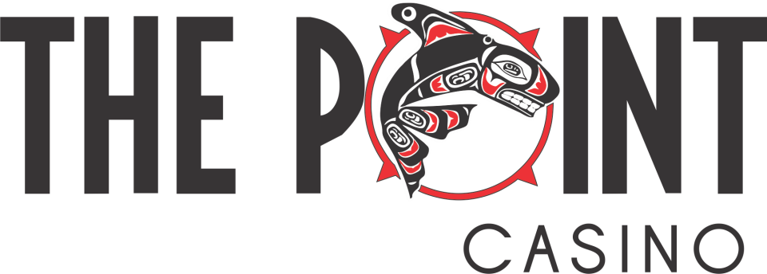

The following are the service standards that we believe establish an unparalleled guest service experience for The Point Casino. These standards serve as the defining criteria for every interaction a team member has with a guest.

- Attitude – Team members demonstrate a polite and positive attitude by expression, gestures, or remarks.

- Language - Team members speak clearly and naturally, with appropriate and conversational phrases without using slang. Additionally, team members should limit conversation with one another keeping it professional when team member to team member conversation is appropriate or necessary. Team members should engage guests in conversation by inquiring about their visit to the casino and suggest things to do while at the property.

- Greeting and closing – Each guest should be greeted properly at the beginning of any interaction. A greeting is defined as an acknowledgment of a guest at the beginning of an interaction or transaction. A closing is defined as the verbal end of an interaction.

- Interaction - Team members anticipate logical guest needs and offers to meet needs without being prompted by the guest.

- Knowledge of the property – Team members should be knowledgeable about the location of amenities, function of all departments, and all events and promotions at the casino. Team members should also be aware of the details of the new facility i.e., opening date, new venues and amenities.

- Appearance - Team members maintain a clean, crisp appearance that meets the basic uniform standards required with visible name tag. Team members should also maintain good posture, no slouching or leaning, and should appear attentive and ready for guests at all times.

- Cleanliness of work areas – Each area of the property should be clean at all times.

- Passion and Engagement – Team members should be energetic, engaged, and passionate about their work at The Point Casino.

